**Y.S.P.E Yorkshire Sculpture Park Event**

**(To the tune of YMCA)** [**https://www.youtube.com/watch?v=cj5dkmB34ko**](https://www.youtube.com/watch?v=cj5dkmB34ko)

‘Involvement’, there’s no need to feel down,

I said, involvement, pick yourself off the ground

I said involvement cause your part of the group

There’s no need to be unhappy

‘Involvement’ there’s a place you can go,

I said ‘Involvement’, when your life’s feeling low

*‘You can drive there as IPC have been kind*

*They say have a very good time’*

It’s fun to go to the YSPE

It’s fun to go to the YSPE

They have cameras and things

And picnics to enjoy

You can hang out with all the boys.

It’s fun to go to the YSPE

It’s fun to go to the YSPE

You can achieve all your dreams

You can browse around fields

You can chat about all you’ve seen…...

‘Involvement’

my team listen to me

I said ‘Involvement’

I feel part of the team

I said ‘involvement’

I’ll achieve all my dreams

But you have to avoid sheep poo!!

Involvement…. I feel part of the team

I said ‘Involvement’

I feel part of the team…...

YSPE Its fun to go to the YSPE……refrain

**With Special thanks to all the Service users and staff at Newton Lodge who contributed to:**

**‘Our pathway from ‘apart’ to being ‘a part’ of the Big Get Together’**

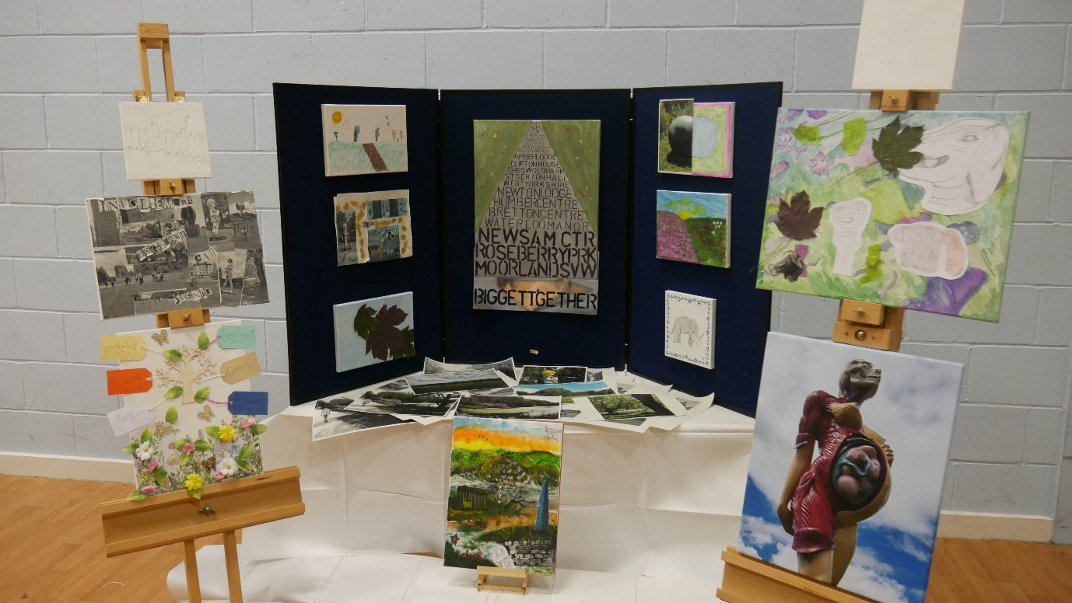

**Including:**

Appleton Chippendale Bronte Priestley Hepworth Waterton and Johnson wards

JL, DC, KT, MB, LD, NF, SE, VF, AR, SI, UZ

Therapy and Staff Team

KS, CK, SM, AN, SF, AW, JS and DS

Security Team

RJ, LP and SS

Management Team

MM and SH

**Musical arrangement**

P, AW, CK, KS and JS